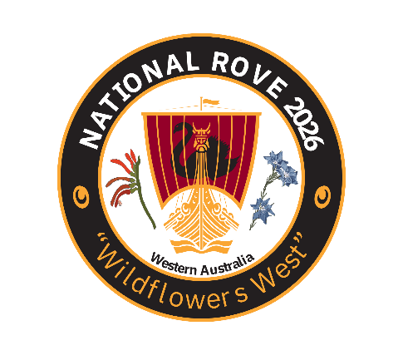
Wildflowers West National Rove 2026
Regalia Order Form
Due by: 15 June 2026 – pre-order Only
First Name:
Last Name:
Rove 2026 Regalia Order – enter number of each item in the boxes |  |  |  |  |  |  |  |  |  |  |  | AUD
Polo $38.50 each
Men's Polo PS35 Sz: |  | XS | S | M | L | XL | 2XL | 3XL | 4XL | 5XL
 | Ruby
 | Ocean
Ladies' Polo PS36B Sz: |  | 6 | 8 | 10 | 12 | 14 | 16 | 18 | 20 | 22 | 24
 | Ruby
 | Ocean
Polo Subtotal:
Black Soft Shell Vest $71.50 each
Men's Vest 1515 Sz: |  | S | M | L | XL | 2XL | 3XL | 4XL | 5XL
 | Black
Ladies' Vest 2515 Sz: |  | 8 | 10 | 12 | 14 | 16 | 18
 | Black
Vest Subtotal:
Hat 3800 $21.45 ea
Hat Size: |  | S | M | L | XL
 | White
Hat Subtotal:
Umbrella 110485 $44.00 ea
Number:
Umbrella Subtotal:
Grand Total:
Payment by Direct Deposit preferred (cheques payable to WA Rover Owners Club), please use your Surname in the reference field to:
WAROC Rove 2026 BSB: 036 041 ACCT: 117373
Email order form to warove2026@gmail.com Or post to PO Box 1090, Victoria Park, WA 6981

