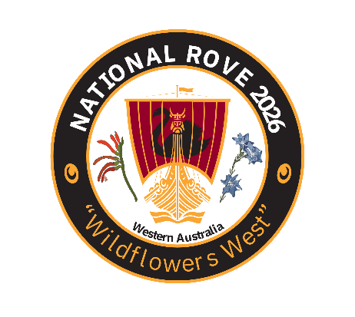
Wildflowers West National Rove 2026
Registration Form
Due by: 31 May 26
We look forward to seeing you here in the “City of Light”, Perth, WA. Come explore the beauty of the King’s Park , affording wonderful views over the Swan River, Whiteman Park and the Eastern Hills with us. The cost is $260 per person. Payment Schedule: deposit $50/person by 31st May 2026, pay the residual by 31st of July 2026.
Attendee 1:
Attendee 2:
Address:
Contact Information:
Home ph: | Mobile: | Email:
Dietary requirements?:

Car Information:
Model: | Year: | Registration Number:

Payment by Direct Deposit preferred (cheques payable to WA Rover Owners Club), please use your Surname in the reference field to:
WAROC Rove 2026 BSB: 036 041 ACCT: 117373
Amt paid Deposit: Balance: Full Amount:
Forward the completed registration to warove2026@gmail.com, or post to PO Box 1090, East Victoria Park, WA 6981

