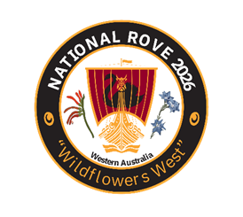
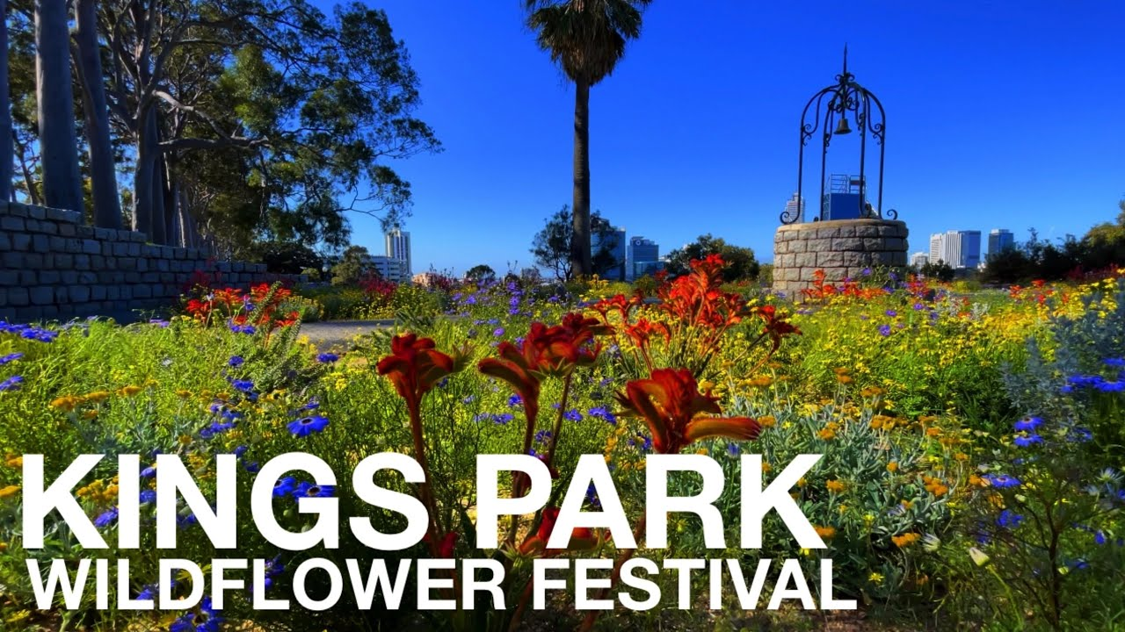
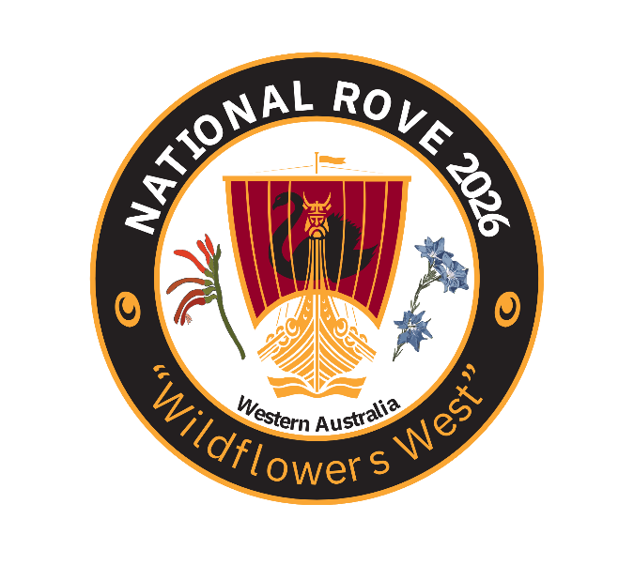
Western Australian Rover Owners’ Club Invites All Australian & New Zealand Rover Enthusiasts to:
2026 National Rove Wildflowers West
Bulletin 2

18th to the 21st of September 2026
Registration, Hotel Bookings, Nullarbor Convoy and Regalia
(forms at end of this bulletin)
Program in Brief:
18/09/26 Friday | Check-in from 2pm at the Pagoda Resort & Spa and 5:30pm Meet & Greet in the ballroom for canapes & camaraderie.
19/09/26 Saturday | Buses to King’s Park Wildflower Festival walking tour & on to Whiteman Park & the WA Motor Museum. Buffet dinner and shed tour at the Veteran & Classic Car Club.
20/09/26 Sunday | Show-n-Shine Rovers in the Eastern Hills followed by a self-paced Driving Tour of Bickley Valley. Formal dinner at the Pagoda.
21/09/26 Monday | Farewell Breakfast at the Pagoda. $28 to those not paying for it in their accommodation.
We Got Ourselves A Convoy – from the Eastern States to Perth
Francis Birtles did it in 28 days in the 1912 with driver Syd Ferguson and a Brush Runabout!
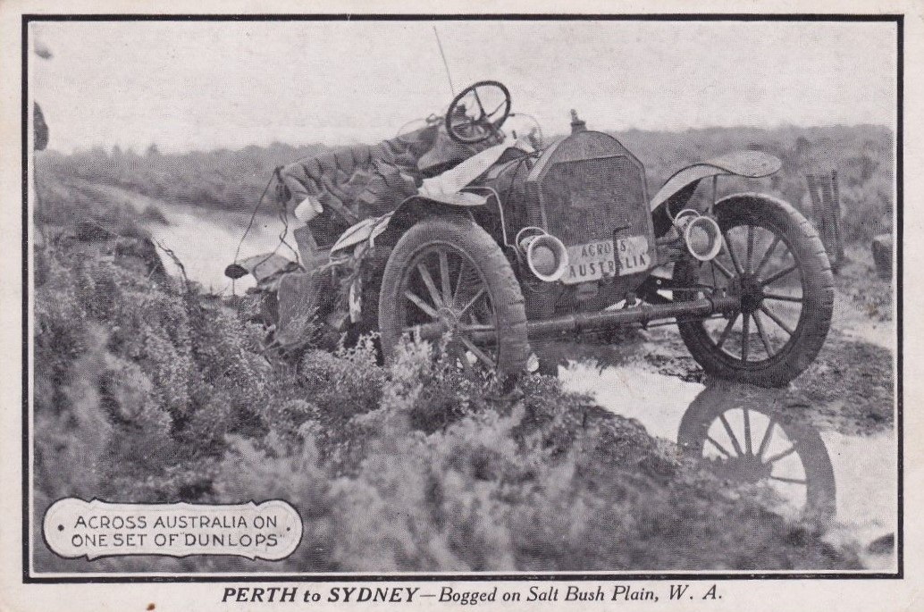
Now it’s time for the classic Rovers to enjoy the tarmac he didn’t have!
A convoy across the Nullarbor is being planned. Tony Cope has recently driven his Jensen Interceptor to and from Perth with other Jensen enthusiasts, and has volunteered to organise a convoy for the WA Rove if there is sufficient interest.
It is planned that all those wishing to convoy across from the east coast meet at Ceduna, and then travel about 450 km per day to reach Perth in five days. This allows a leisurely morning start and getting to the next stop mid-afternoon, breakdowns notwithstanding! The overnight stops will be at roadhouses that offer both accommodation and camping to suit all. It will be a loose convoy in that we travel at speeds that suit the car and passengers with a catch up over dinner - and perhaps at stops along the way. It will be a fun way to get to Perth enjoying the company of other Rover enthusiasts and having help should it be needed.
If you are interested please email Tony Cope on tonywcope@gmail.com or call 0448 400 160.
We also have some folk planning a convoy from SA! Safe and enjoyable journeying everyone!
Now back to business.
Step 1 - Registering:
Registration and deposit deadline 31 May 2026.
The registration fee per person will be $260, and will cover dinner on all 3 days, the guided wildflower tour of Kings Park (with lanyard), free entrance to the Whiteman Park Motor museum (with lanyard), the bus rides for Saturday and the welcome packs. A deposit of $50 per person will be required.
We need separate payments for registration and regalia please.
The preferred method of payment is EFT.
Bank Transfer details: BSB: 036 041 Westpac Inglewood,
Account No. 117373.
Alternatively, make cheques payable to the WA Rover Owners' Club
Postal Address: WAROC, PO Box 1090, East Victoria Park, WA 6981
Contacts: warove2026@gmail.com
Jenny Albert, WAROC Events-Coordinator, 0423 181 401
Graham Bryder, WAROC Treasurer, 0468 475 659
All Bulletins and files can be downloaded from:
https://waroc.org.au/2026-national-rove/

Step 2 - Accomodation:
Pagoda Resort & Spa, Como WA, (08) 9367 0300.
All hotel bookings must be secured by the 17 August 2026.
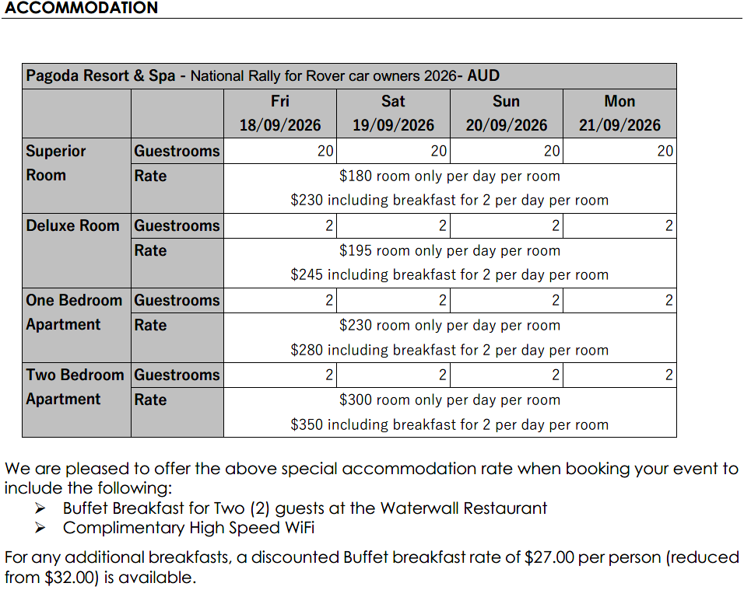
To book accommodation at the Pagoda Resort and Spa view the rooms at Pagoda Resort & Spa Room Types. Next, email: rooms@pagoda.com.au & quote the event name ‘National Rally for Rover Car Owners 2026’ in the subject line of the email. Please state the room type, the dates you wish to book for, the number of people in your party and whether you wish to book the secure parking @ $10/24 hrs. The Pagoda team will then email you your booking reference number and the invoice for the deposit required to hold the room.
Please note that there is on-street parking all around the resort, but if you would like to book secure parking it will be at $8 for the day or $10 for 24 hr parking. You should discuss this with the hotel while booking if you want to use the garage facility.
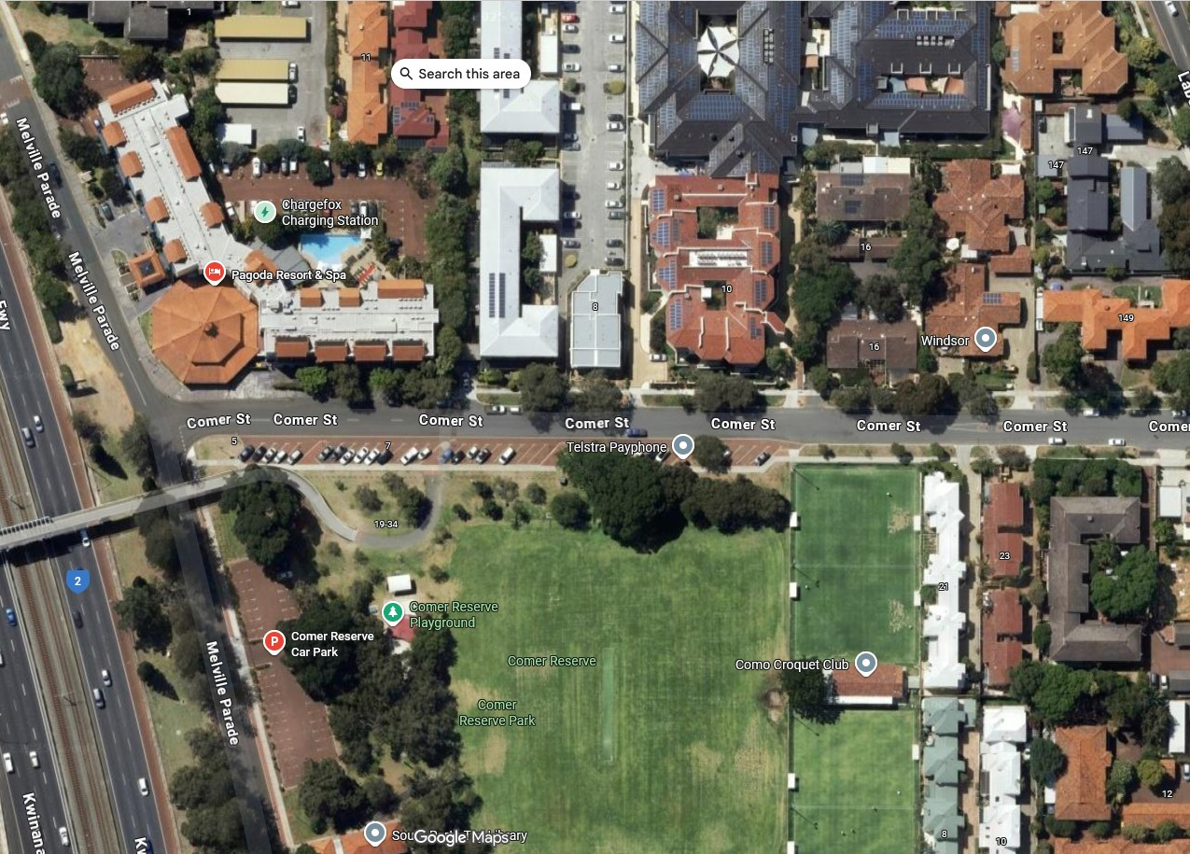
On-street parking around the Pagoda:
On-street parking
Secure Parking behind fencing

Step 3 – See the separate Regalia section at the end of this bulletin:
Please get your orders in early, it will be by pre-order only again this year.
Remember it will be Spring in WA, ie anything from frigid rain and wind storms to 30 C and sunny, come prepared!
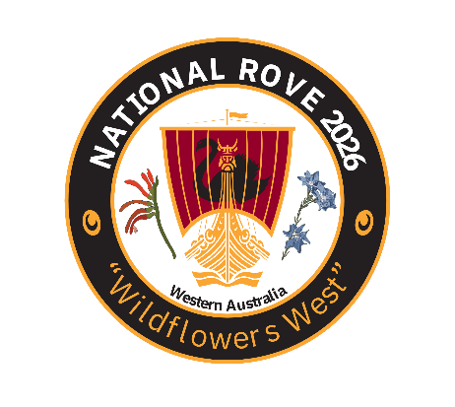
Wildflowers West National Rove 2026
Registration Form
Due by: 31 May 26
We look forward to seeing you here in the “City of Light”, Perth, WA. Come explore the beauty of the King’s Park , affording wonderful views over the Swan River, Whiteman Park and the Eastern Hills with us. The cost is $260 per person. Payment Schedule: deposit $50/person by 31st May 2026, pay the residual by 31st of July 2026.
Attendee 1:
Attendee 2:
Address:
Contact Information:
Home ph: | Mobile: | Email:
Dietary requirements?:

Car Information:
Model: | Year: | Registration Number:

Payment by Direct Deposit preferred (cheques payable to WA Rover Owners Club), please use your Surname in the reference field to:
WAROC Rove 2026 BSB: 036 041 ACCT: 117373
Amt paid Deposit: Balance: Full Amount:
Forward the completed registration to warove2026@gmail.com, or post to PO Box 1090, East Victoria Park, WA 6981
National Rove 2026 Regalia – Pre-Order Only, Available at check-in 18/09/26

Long Sleeve Polo - $38.50 inc gst. 60% Cotton/40% Polyester easy care, breathable. Ladies is more fitted and has slightly different v-neckline and 2 low buttons. Colours: Ruby & Ocean Blue. Measure ½ chest 2.5 cm below sleeve attachment.

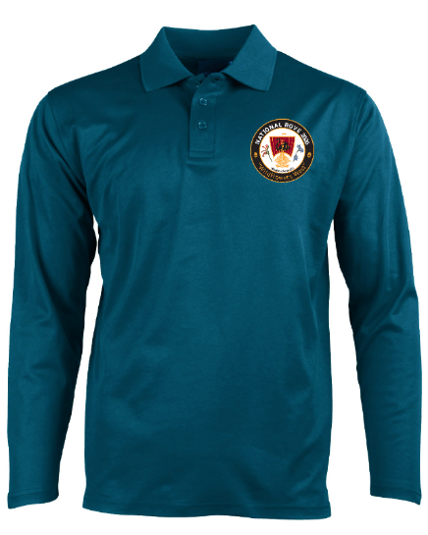
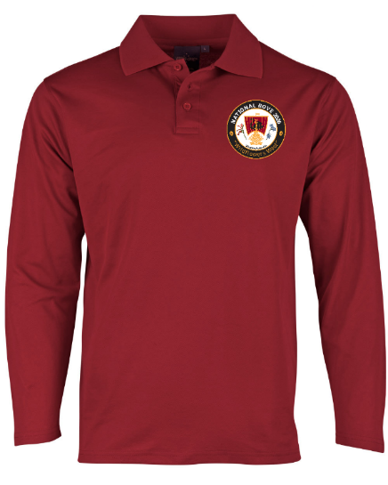
Men’s/Unisex PS35

Size: | XS | S | M | L | XL | 2XL | 3XL | 4XL | 5XL
1/2 chest (cm) | 51 | 53.5 | 56 | 58.5 | 61 | 63.5 | 66 | 68.5 | 71
Length (cm) | 68/71 | 70/73 | 72/75 | 74/77 | 76/79 | 78/81 | 80/83 | 82/85 | 84/87

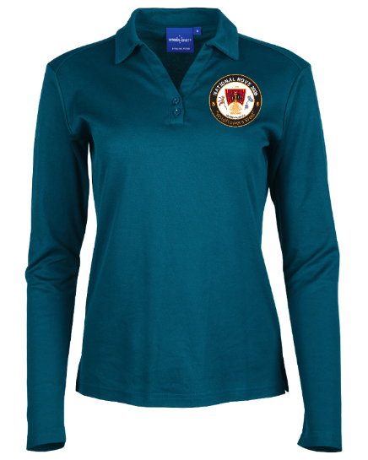
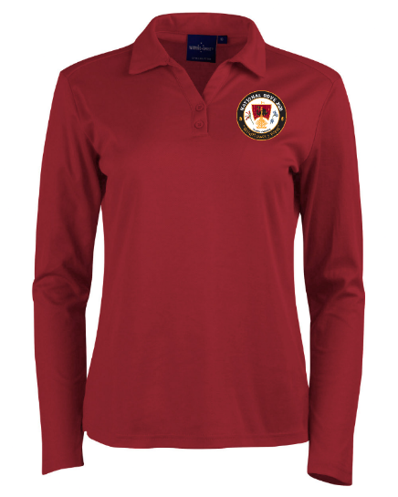
Ladies’ PS36B

Size: | 6 | 8 | 10 | 12 | 14 | 16 | 18 | 20 | 22 | 24
1/2 chest (cm) | 43.5 | 46 | 48.5 | 51 | 54 | 57 | 60 | 63 | 66 | 69
Length (cm) | 60 | 62 | 64 | 66 | 68 | 70 | 71 | 72 | 73 | 74

Black Soft Shell Vest - $71.50 inc gst. Polyester/elastane outer lined with polyester fleece, water repellent and wind resistant, waterproof zippered pockets chest & 2 sides, concealed waterproof hood. To take a 1/2 chest measurement (cm), measure 2.5 cm down from sleeve attachment, variation +/- 1 cm.
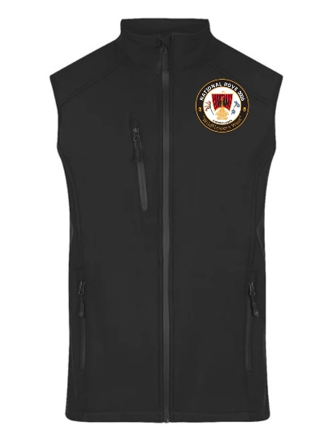
Men’s 1515

Size: | S | M | L | XL | XXL | 3XL | 5XL | 6XL | 7XL | 8XL
1/2Chest (cm): | 54 | 56.5 | 59 | 61.5 | 64 | 66.5 | 72.5 | 75.5 | 78.5 | 81.5
Length (cm): | 76 | 78 | 80 | 82 | 84 | 86 | 89 | 90 | 91 | 92

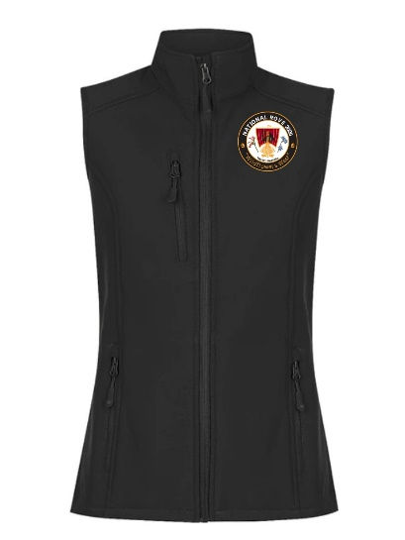
Ladies’ 2515

Size: | 8 | 10 | 12 | 14 | 16 | 18 | 20 | 22 | 24 | 26
1/2Chest (cm): | 48 | 50.5 | 53 | 55.5 | 58 | 60.5 | 63 | 65.5 | 69.5 | 73.5
Length (cm): | 67.5 | 69 | 70.5 | 72 | 73.6 | 75 | 76 | 77 | 78 | 79

Wide Brim Slouch Hat 3800 – $21.45 inc gst. Polyester/cotton with cotton sweatband, 8 cm brim.

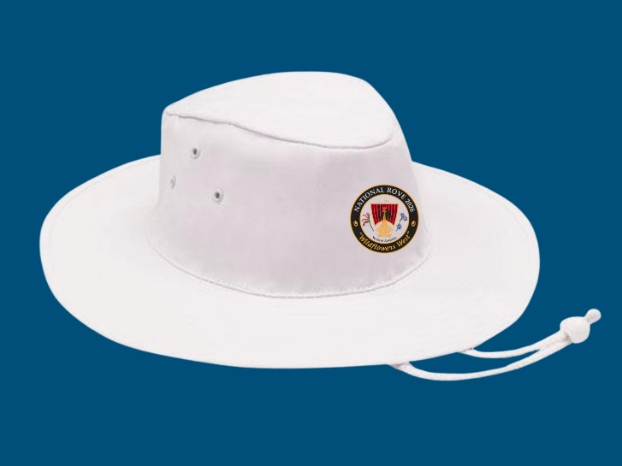

Size: | S | M | L | XL
Diameter (cm): | 55 | 57 | 59 | 61

Umbrella 110485 – $44.00 inc gst. Automatic opening, 130 cm open, polyester canopy, fibreglass frame, EVA hand grip.
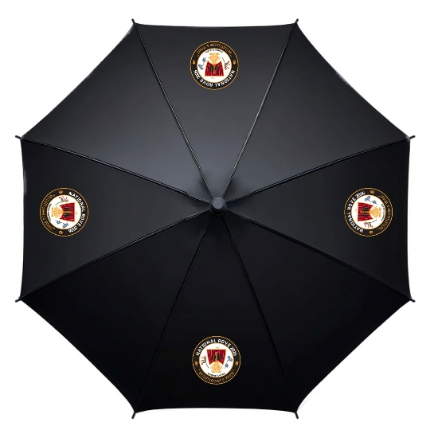
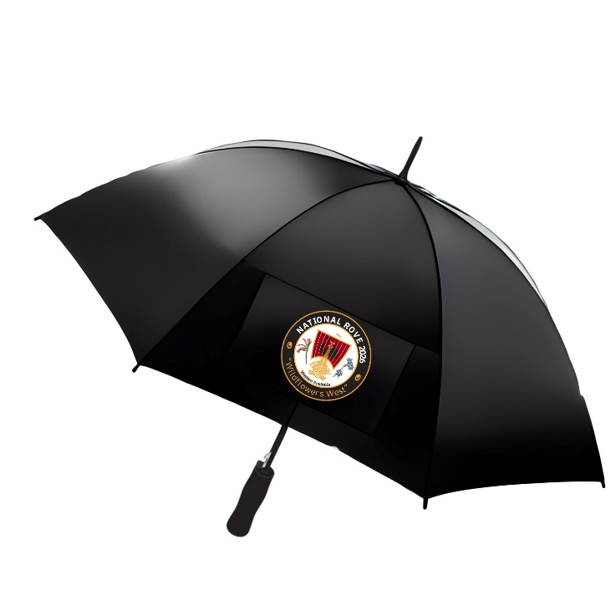
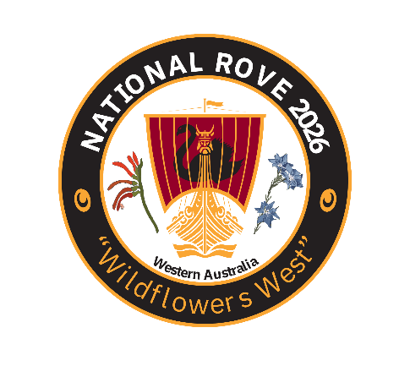
Wildflowers West National Rove 2026
Regalia Order Form
Due by: 15 June 2026 – pre-order Only
First Name:
Last Name:
Rove 2026 Regalia Order – enter number of each item in the boxes |  |  |  |  |  |  |  |  |  |  |  | AUD
Polo $38.50 each
Men's Polo PS35 Sz: |  | XS | S | M | L | XL | 2XL | 3XL | 4XL | 5XL
 | Ruby
 | Ocean
Ladies' Polo PS36B Sz: |  | 6 | 8 | 10 | 12 | 14 | 16 | 18 | 20 | 22 | 24
 | Ruby
 | Ocean
Polo Subtotal:
Black Soft Shell Vest $71.50 each
Men's Vest 1515 Sz: |  | S | M | L | XL | 2XL | 3XL | 4XL | 5XL
 | Black
Ladies' Vest 2515 Sz: |  | 8 | 10 | 12 | 14 | 16 | 18
 | Black
Vest Subtotal:
Hat 3800 $21.45 ea
Hat Size: |  | S | M | L | XL
 | White
Hat Subtotal:
Umbrella 110485 $44.00 ea
Number:
Umbrella Subtotal:
Grand Total:
Payment by Direct Deposit preferred (cheques payable to WA Rover Owners Club), please use your Surname in the reference field to:
WAROC Rove 2026 BSB: 036 041 ACCT: 117373
Email order form to warove2026@gmail.com Or post to PO Box 1090, Victoria Park, WA 6981

