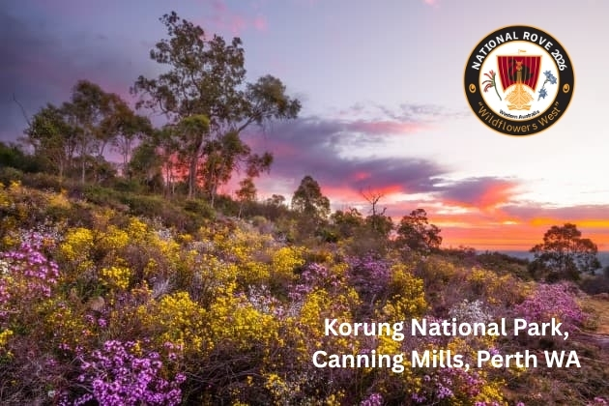
Western Australian Rover Owners’ Club
2026 National Rove Wildflowers West
18th to the 21st of September 2026
Bulletin 4 – Bits & Bobs

All previous bulletins & forms are available at: (https://waroc.org.au/2026-national-rove/)
Just a few reminders now that the end of May is here! Thank you to all who have registered and sent their deposits and regalia forms. The end of this month is when we would like to include you in our planning, though we will try to accommodate stragglers!
And … as we have been asked … yes, we are still planning to go ahead despite the good ol’ US of A.
It has come to our attention that both the registration form and regalia form have an incorrect bank account name, mea culpa. Please note that this will not affect those people who have already paid … if Graham sent you a receipt, all is well. It is just that one of our member’s banks refused to pay the EFTPOS request due to the mismatch in names. I am attaching a registration form and regalia form with the correct account name.
As at the NSW Rove, all regalia must be pre-ordered.
Date reminders
Registration Forms & deposit 31 May 2026
Regalia Forms & payment 15 June 2026
Final Payments for Registration 31 July 2026
Accommodation Booking @ Pagoda 17 August 2026
We are planning a convoy run (Bulletin 3) on the Monday after the breakfast, email us if interested.
The lovely photo above from Korung NP is a mere hop, skip and a jump from the Pagoda Resort and Spa, near the Kalamunda and the Bickley Valley and would make a lovely day trip. We will be skirting the edge of it on our scenic drive back from the Show-n-Shine on Sunday. For more post-Rove roaming suggestions see Bulletin 3.
Any questions please feel free to contact us:
warove2026@gmail.com
Jenny Albert, events-coordinator@waroc.org.au, 0423 181 401
Graham Bryder, treasurer@waroc.org.au, 0468 475 659
